Drupal 7: Guide for Content Management

Contents

Getting Started 3

Content types: 4

Basic page content type: 5

Product content type: 14

News content type: 15

Blog entry content type: 16

Employee content type: 18

Working with multi-lingual content *(not block)* 19

Anonymous Comments & Approval 20

Blocks *(Front-page content, product contact form, left-sidebar content, etc.)* 21

Edit/configure block’s content: 21

Translate block’s content: 22

Menu Structure 24

Search Engine Optimization (SEO) 25

Keywords: 25

Image carousel/slider 26

Accordion 27

# Getting Started

To login visit, <http://www.gilbarco.com/us/user>

In above URL, ‘us’ can be replaced with any other region like au, ar, br, eu, mea or sea.

Once logged in, you will be able to see an administration menu (highlighted by blue box) at the top of your page.

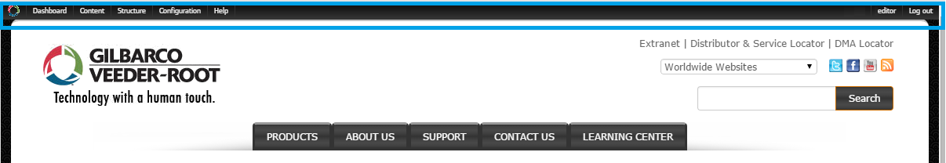

The administration menu will give you access to all functionality that your account is entitled to:

1. Dashboard: This page shows a list of recent content. At the bottom of the list, there is a ‘More’ link, which will take you to content listing page which can be used to see all available content on the site.
2. Content: This menu contains links to create new content: Basic page / News / Employee / Product.
3. Structure: Using this menu, website’s structure can be managed/changed.
4. Configurations: Please ignore this menu item as it strictly should not be played with.
5. Help: Some documentation of features and functionalities offered by Drupal

# Content types:

As an editor, following types of content have been enabled:

1. *Basic page:* Used for creating any page that does not fall under Product or News type of content
2. *Product:* Detailed content for a particular product can be created using Product content type
3. *News:* Content of type New, Event or Press Release can be created.
4. *Employee:* Create content for an employee to be featured on ‘Careers at Gilbarco Veeder-Root’ page (<http://www.gilbarco.com/us/about/careers-gilbarco-veeder-root>)

Sections below will help you how to create content of above mentioned types.

To edit any existing content, navigate to the content you would like to edit and then click on ‘Edit’ link which appears just below breadcrumbs.

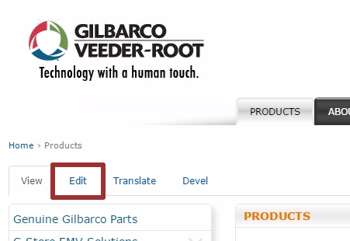

## Basic page content type:

This content type can be used to create generic content. E.g. Product group pages, About Us pages, Support pages.

To create a basic page, using admin menu, navigate to: Content > Add content > Basic page

Fields:

1. *Title:* This servers as the title of the page
2. *Main image:* Hero image can be uploaded in this field. After uploading an image, ‘Alternate text’ and ‘Title’ attributes of the image can be set.
3. *Body:* Rich textual content (text/images/video) can be enter into this text area using provided editor.
   1. Text format: Below the body field, you will see a dropdown with label ‘Text format’. Use this to specify the type of content in the body field.

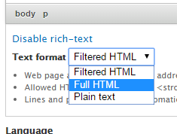

* + 1. *Filtered HTML:* This will limit the HTML tags used in body field to: <a>, <em>, <strong>, <cite>, <blockquote>, <code>, <ul>, <ol>, <li>, <dl>, <dt> and <dd>.
    2. *Full HTML:* All HTML tags, JavaScript code, CSS code will be allowed without any restrictions.
    3. *Plain text:* No HTML tags will be allowed in body field (including images & video).

It is recommended that ‘Full HTML’ should be selected since most of our content is using variety of HTML tags.

* 1. Adding/Uploading an image: To add and show an image you must first select full HTML text format.

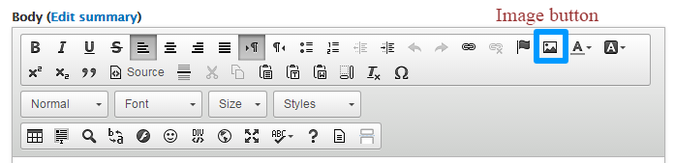

* + 1. On the editor’s toolbox, click on image button (highlighted by blue box in picture above)
    2. This will open a popup window as shown below:  
         
         
       Here you can either choose to:

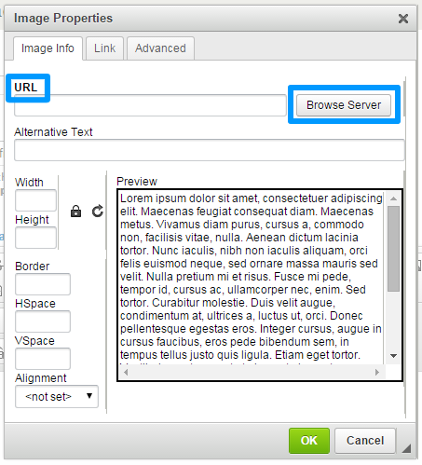

* + - 1. Directly enter the URL of an image in ‘URL’ text field. *E.g. http://example.com/test1.png*
      2. Click ‘Browse Server’ button to upload an image or select an already uploaded image. You will see another popup window as below:  
           
           
           
           
           
           
           
           
           
           
           
           
           
           
           
           
           
           
           
           
           
         To Upload:

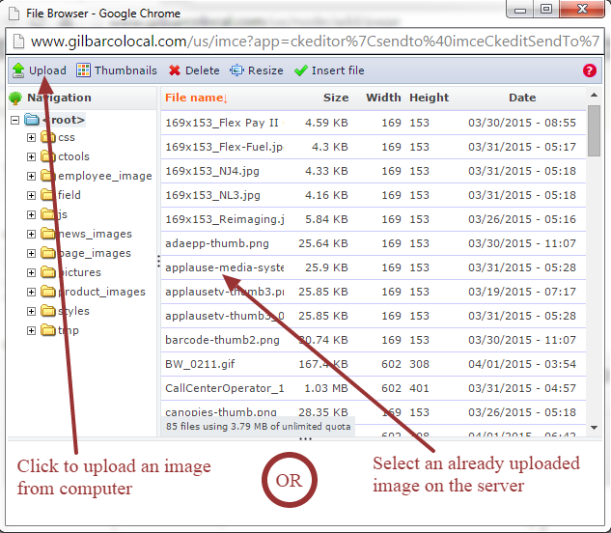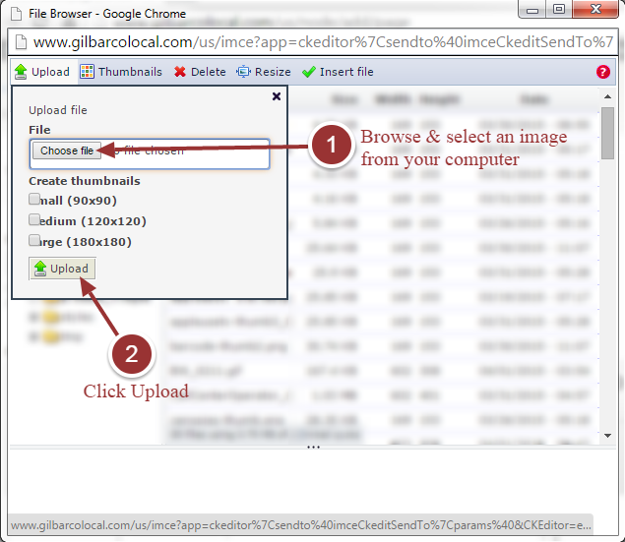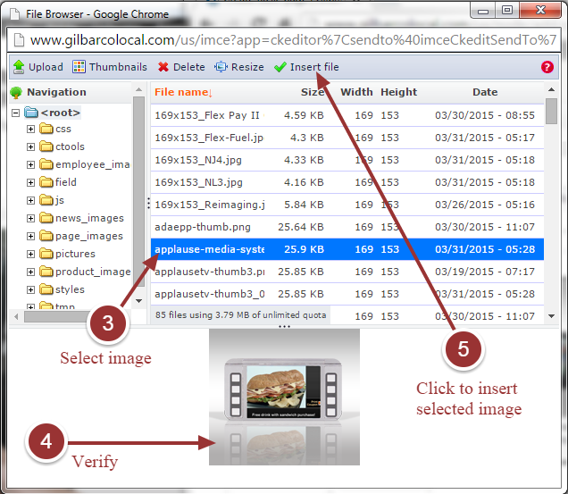

* + - 1. The selected image will appear in earlier popup window. Follow instructions in image below and click OK to insert image into editor:

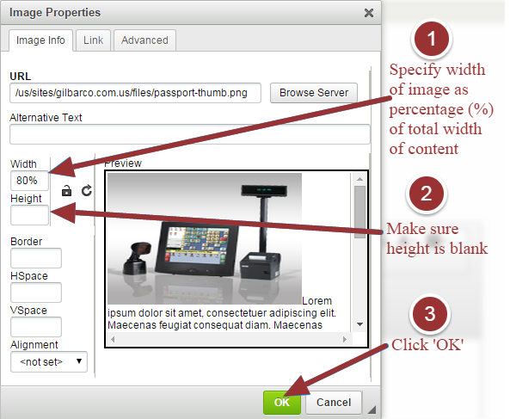

* 1. Points to remember:
     1. Regardless of how the image & text appears in the editor, actual appearance can be verified by clicking ‘Preview’ button at the end of the page.
     2. It is recommended to keep use of WYSIWYG editor for styling content to a bare minimum. This will help in maintaining style of content consistent with that of rest of the site.
     3. Do not copy-paste content directly for a word document into the editor. Instead use the ‘paste from word’ button on editor’s toolbar.



* + 1. Only the width of an image should be specified and height field should be left blank. This helps in maintaining aspect-ration of the image when it scales as per device width.
    2. The width of an image should be specified as percentage (%) of total width of body content, as mentioned in the image above. This helps the image to scale according to device width and maintain responsiveness of the layout.
    3. If at all it is required to specify the width of an image in pixels (px), such width should not be more than 300px.
    4. Using upload method specified above, any file can be uploaded. Most common requirements are to upload images and PDF files. While images are uploaded under <root> directory, it is recommended to keep/upload PDF files in a sub-directory named ‘pdfs’. If a directory by this name does not exist, please request for the same.

1. *Language (for multilingual sites only):* Select the language of the content. This should default to ‘English’ or the default language of your website.
2. *CSS only*: This field is intended for a very specific purpose. As you might be aware of, the hero images are hidden on small screen. If not, then this field can be ignored for you website.   
   Below steps should be followed to enable/show hero image on small screen.
   1. Select ‘Full HTML’ text format
   2. Click on ‘Disable rich-text’
   3. Enter below code in ‘CSS only’ textarea:

|  |
| --- |
| <style type**="text/css">**  **@**media(max-width: 991px)**{**div**.**field-type-image**{display:block!important;}}**  </style**>** |

1. *JS only:* For optimized loading of website pages, all JavaScript code is loaded towards the end of the page. This field facilitates adding JS/jQuery code after Drupal JavaScript and jQuery libraries are loaded. This field should only be used to add non-rendering JavaScript code.
2. *Menu settings*: In order to link this page to left navigation menu, so that it has a way to be navigated to, a menu link can be created as below:  
   *Important: The menu structure is used to display breadcrumbs correctly.*
   1. Click on ‘Menu settings’ tab
   2. Check ‘Provide a menu link’ checkbox
   3. Fill ‘Menu link title’: used to give the menu link a name, which is mostly same as title of the page
   4. Using ‘Parent item’ dropdown, select an existing menu link under which the link to current page should appear. It is important to know the website’s information architecture to place the current page correctly below its parent. In case of multilingual websites, correct parent belonging to same language as that of current page must be selected.
   5. Weight dropdown can be used to specify the heaviness of the menu item which is used to set the position of a menu link under its parent i.e. among sibling menu links. Higher the number, lower the position of menu link
   6. After you create a menu link: We have two menus on the site; one for navigation on small screen and other for large screen. If the menu item is not showing in these menus, make sure the selected parent element has ‘Expanded’ checkbox checked as described in steps below:
      1. Structure > Menus > Main menu (or News)
      2. Search for the menu link you created using menu title
      3. Check the ‘Expanded’ checkbox next to the menu link of its parent menu item
      4. Click ‘Save configuration’ at the bottom of the page
3. *Meta* *tags*: The fields under this section are used for SEO purpose and can be accessed by clicking on ‘Meta tags’ tab. It is recommended to fill ‘Page title’, ‘Description’ and ‘Keyword’ fields. The description/purpose of every field is mentioned below each field. Please note that default values for page title and description fields are specified via tokens/placeholders as show in image below.

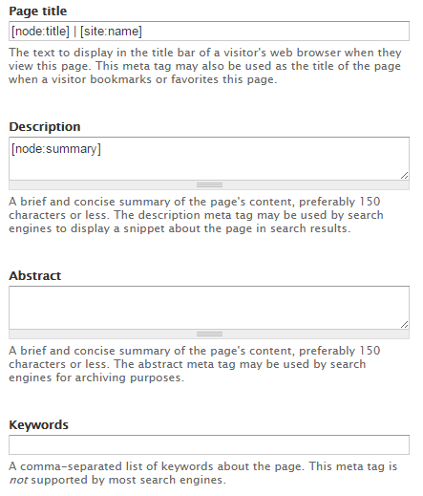

1. *URL* *path* *settings*: This tab provides a feature to set URL for current page. By default, an automatic URL will be generated having structure ‘content/<title-of-the-page>’. This is a path relative to base URL of the site (e.g. <http://www.gilbarco.com/us/> is a base URL). If you would like to manually set URL, uncheck ‘Generate automatic URL alias’ checkbox and enter a path relative to base URL of the site in URL alias textfield. For example, if you like a page in Gilbarco US website to have URL like ‘http://www.gilbarco.com/us/example1/example2’ then enter ‘example1/example2’ in URL alias textfield. By default, if you edit an existing page and change its URL via ‘URL path settings’, then old URL is automatically redirect to new URL. If you re-edit the page, you will see an entry of old URL under ‘URL redirects’ tab. You can modify or delete this URL redirect as required.
2. *URL redirects*: Using URL redirects, you can make your content available to your site visitors using multiple links. For example, if you have a page (abc) that is available in two different sections (lmn & xyz), you can add URL redirects for page *abc* from *lmn/abc* and *xyz/abc* so that both point to your page. Image below shows an example of URL redirect entry:  
   To add a URL redirect, click on ‘Add URL redirect to this node’. You will be taken to a form as shown in image below:  
     
   Please note that a URL redirect can only be added from the same domain (as your website) to an existing Drupal content or external URL as mentioned in descriptions of ‘From’ and ‘To’ fields.

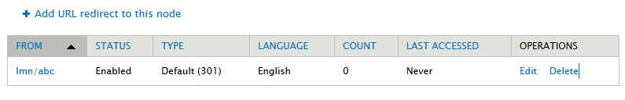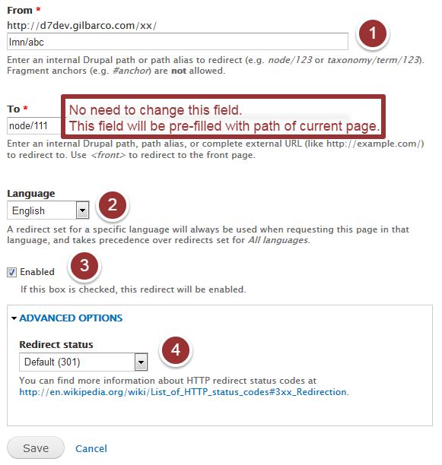

## Product content type:

This content type is used to create product content only.

To create product page, using admin menu, navigate to: Content > Add content > Product

Fields:

1. *Title*: Name of the product should be specified in this field
2. *Image*: Picture of the product can be uploaded in this field. After uploading an image, ‘Alternate text’ and ‘Title’ attributes of the image can be set.
3. *Body*: Rich textual content (text/images/video) can be enter into this text area using provided editor. For details, refer section #3 of basic page content type.
4. *Language (for multilingual sites only):* Select the language of the content. This should default to ‘English’ or the default language of your website.
5. *CSS* *only*: Refer section #5 of basic page content type.
6. *JS only:* For optimized loading of website pages, all JavaScript code is loaded towards the end of the page. This field facilitates adding JS/jQuery code after Drupal JavaScript and jQuery libraries are loaded. This field should only be used to add non-rendering JavaScript code.
7. *Menu* *settings*: In order to link this page to left navigation menu, so that it has a way to be navigated to, a menu link can be created as described in section #6 of basic page content type.  
   *Important: The menu structure is used to display breadcrumbs correctly.*
8. *Meta* *tags*: Refer section #7 of basic page content type.
9. *URL* *path* *settings*: This tab provides a feature to set URL for current page. By default, an automatic URL will be generated having structure ‘products/<title-of-the-page>’. Refer section #8 of basic page content type for details.
10. *URL redirects*: Refer section #10 of basic page content type.

## News content type:

This content type is used to create content of type News, Event & Press Release. To create a news/event/press-release, using admin menu, navigate to: Content > Add content > News

Fields:

1. *Title*: Title of the article.
2. *Subtitle*: A short, single-line sub-title can be entered in this field.
3. *Language (for multilingual sites only):* Select the language of the content. This should default to ‘English’ or the default language of your website.
4. *Type*: Select the category of news article: News/Event/Press release.
5. *Post* *Date*: The date on which article is posted on. Apart from display, this date is also used for sorting/ordering purpose.
6. *Image*: An image of dimension 200 x 170 pixels can be uploaded. This field is primarily used in press release content.
7. *Body*: Rich textual content (text/images/video) can be enter into this text area using provided editor. For details, refer section #3 of basic page content type.
8. *Menu* *settings*: In order to link this page to left navigation menu, so that it has a way to be navigated to, a menu link can be created as described in section #6 of basic page content type.   
   *Important: The menu structure is used to display breadcrumbs correctly. In case of press-release article, it should be noted that its link does not show in left-navigation. Menu links of press-releases should be hidden manually else they will appear in left navigation. Hence, to hide a menu link, follow below mentioned steps after saving/creating content:* 
   1. Navigate to: Structure > Menus > News: Depending on your website’s structure, news articles might be placed in other menu structures. E.g. ‘News’ or ‘Main menu’.
   2. Search for title of press-release article (by title)
   3. Uncheck corresponding ‘Enabled’ checkbox
   4. Click ‘Save configuration’
9. *Meta* *tags*: Refer section #7 of basic page content type.
10. *URL* *path* *settings*: This tab provides a feature to set URL for current page. By default, an automatic URL will be generated having structure ‘news/<title-of-the-page>’. Refer section #8 of basic page content type for details.
11. *URL redirects*: Refer section #10 of basic page content type.

## Blog entry content type:

This content type is used to create a blog article or entry. To create a blog entry page, using admin menu, navigate to: Content > Add content > Blog entry

Fields:

1. *Title*: Title of the blog article.
2. *Language (for multilingual sites only)*: Select the language of the content. This should default to ‘English’ or the default language of your website.
3. *Blog Thumbnail*: An image of dimension 100 x 100 pixels can be uploaded. This field is displayed on blog article listing page. E.g. /blog.
4. *Body*: Rich textual content (text/images/video) can be enter into this text area using provided editor. For details, refer section #3 of basic page content type.
5. *Menu* *settings*: In order to link this page to left navigation menu, so that it has a way to be navigated to, a menu link can be created as described in section #6 of basic page content type.   
   *Important: The menu structure is used to display breadcrumbs correctly. In case of blog article, it should be noted that its link does not show in left-navigation. Menu links of blog article should be hidden manually else they will appear in left navigation. Hence, to hide a menu link, follow below mentioned steps after saving/creating content:* 
   1. Navigate to: Structure > Menus > Main menu: Depending on your website’s structure, blog articles might be placed in other menu structures. E.g. ‘News’ or ‘Main menu’.
   2. Search for title of blog article (by title)
   3. Uncheck corresponding ‘Enabled’ checkbox
   4. Click ‘Save configuration’
6. *Meta* *tags*: Refer section #7 of basic page content type.
7. *URL* *path* *settings*: This tab provides a feature to set URL for current page. By default, an automatic URL will be generated having structure ‘news/<title-of-the-page>’. Refer section #8 of basic page content type for details.
8. *URL redirects*: Refer section #10 of basic page content type.
9. *Comment settings*: If your website has comment feature enabled for blog articles, select ‘Open’ else select ‘Closed’.
10. *Authoring information*: It is possible to post the blog article in name of a user different than the one currently logged in. To do so, type in the name of the user in ‘Authored by’ field and wait for the autocomplete list to show suggestion. Select a user from the suggestion. Selecting a user’s name from within the suggestions (only) is mandatory. Similarly, a desired post-date can be supplied via ‘Authored on’ field. E.g. 2015-09-21 15:51:12 +0530. The date format is YYYY-MM-DD and +0530 is the time zone offset from UTC. Leave blank to use the time of form submission.

## Employee content type:

This content type is used to create testimonial content for an employee to be featured on ‘[Careers at Gilbarco Veeder-Root](http://www.gilbarco.com/us/about/careers-gilbarco-veeder-root)’ page.

To create an employee content, using admin menu, navigate to: Content > Add content > Employee

Fields:

1. *Name*: Full name of the employee
2. *Language (for multilingual sites only):* Select the language of the content. This should default to ‘English’ or the default language of your website.
3. *Position*: Role or Designation of the employee in the organization.
4. *Photo*: Profile picture of the employee (80 x 80 pixels)
5. *Testimony*: A short paragraph on employee’s experience at Gilbarco Veeder-Root. For details, refer section #3 of basic page content type.
6. *Rank*: Enter an integer value used for ordering the testimony display on ‘[Careers at Gilbarco Veeder-Root](http://www.gilbarco.com/us/about/careers-gilbarco-veeder-root)’ page. Higher value will appear in the left of list, lower in the right.
7. *Meta* *tags (optional)*: Refer section #7 of basic page content type.
8. *URL* *path* *settings (optional)*: This tab provides a feature to set URL for current page. By default, an automatic URL will be generated having structure ‘employee/<title-of-the-page>’. Refer section #8 of basic page content type for details.
9. *URL redirects*: Refer section #10 of basic page content type.

# Working with multi-lingual content *(not block)*

To view the translations of any content, click on ‘Translate’ tab below breadcrumbs

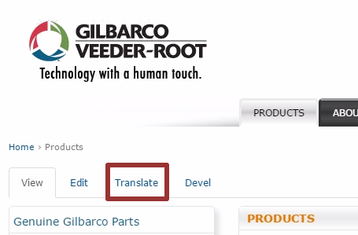

This will show you the translation status of node/content.

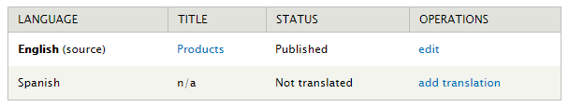

To add a translation, click on ‘add translation’ link of the language you want to add the translated content for. You can use the language toolbar in the header of the site to switch between available translations of the current page/content.

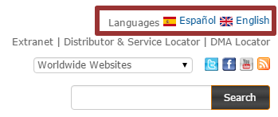

If, for a page/content, a language appears stroked-out/disabled, then translation of the content for that language is missing.



For adding translation of content displayed in blocks, please refer translating block’s content.

# Anonymous Comments & Approval

When an anonymous user comments on your website, the comment is sent for approval. Once the comment is approved, it will show up on your website.

If comments by anonymous users are enabled for your website then a pre-configured email address will receive an email alert. This email alert will also contain a link to queue of unapproved comments.

To view & approve unapproved comments:

1. Navigate to: Content > Comments > Unapproved comments
2. To view the comment, click on its subject. The links below the comment can be used to take required action like approve or delete the comment.
3. Using ‘Unapproved comments’ page, multiple comments can be approved or deleted at once:
   1. Check the checkbox against each comment you want to act on.
   2. From ‘Update Options’ dropdown, select ‘Publish the selected comments’ (to approve) or ‘Delete the selected comments’ (to delete) all selected comments.
   3. Click Update.

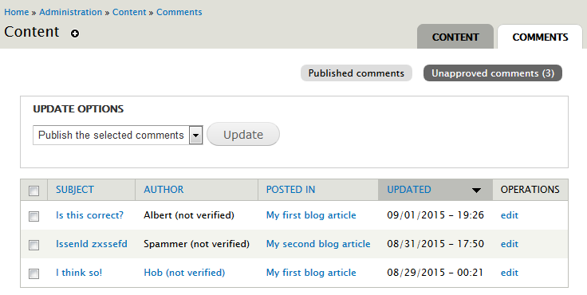

# Blocks *(Front-page content, product contact form, left-sidebar content, etc.)*

Blocks are the boxes of content (such as "Homepage main banner" or "Latest Tweets on homepage") that can be displayed in regions (such as footer or sidebar) on your page.

## Edit/configure block’s content:

To edit a block, hover on the block and you will see block settings/configuration menu icon at top-right corner. Clicking the icon will show the settings menu for the block.

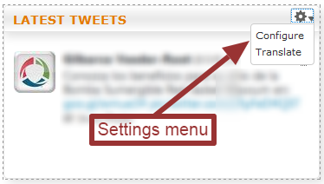

To configure the block, click on ‘Configure’. This will take you to a form page where you will be able to change block’s properties. These properties are described below:

1. Block title: This is the title for your block (e.g. ‘LATEST TWEETS’ in above image). If you enable the option to show a title for your block, this is what will show. To disable the title enter ‘<none>’.
2. Block description: The block description is used primarily to identify this particular block in Drupal admin section (Structure > Blocks). If you had 20 different blocks for example, unique descriptions will help you organize and manage your blocks more efficiently.
3. Block body: The block body is the bulk of your block. For example, if you were creating a block to show latest tweets or an image with a link, the HTML code would be entered in the Block body. Since this field has a WYSIWYG editor, please refer section #3 of basic page content type for details.
4. CSS class(es): This field is used for adding extra CSS class to the block, each CSS class separated by space. A common usage scenario is to disable border & shadow for a block. To do so enter ‘no-border no-shadow’ into this field.
5. Visibility settings:
   1. Pages: The *Pages* setting allows you to restrict which pages this block will be displayed in. For example, to show a block in products section (considering the URL structure is uniform throughout, like <http://www.gilbarco.com/products>, <http://www.gilbarco.com/products/abc>, <http://www.gilbarco.com/products/def/ghi>), select ‘Only the listed pages’ and add following entries, one on each line, in textarea:
      1. products
      2. products/*
   2. Content Types: The *Content types* setting allows you to control which content types this block will appear with.
   3. Roles: The *Roles* setting allows you to specify which types of users can see this block. For example, if you only want logged in users to be able to see the block, you can specify that here.
   4. Users: Each user can be given the ability to customize how your site will display for them, this includes the option to show or hide certain blocks. If you want users to be able to toggle on/off the display of this block, you'll do that within the *Users* settings. But it is best & safest to set this option to ‘Not customizable’.

## Translate block’s content:

If your website is multilingual, it is possible to add translations for block content as well. At first a block will be created in website’s default language. So, when you click on ‘Configure’ option in block’s settings menu, you will be able to edit block’s content in website’s default language only.

To add/edit translated content of a block, click ‘Translate’ option in block’s settings menu. You will see a page similar to one as shown below:

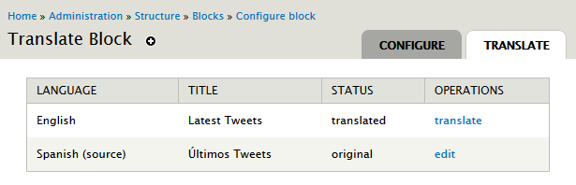

As indicated in the above image, Spanish is source language. To add English translation, click on ‘translate’ in English row and Operations column.

*Please note that, if the translated content needs to have an image other than that already uploaded/present in block content in source language, then the image will have to be uploaded using WYSIWYG editor available on block configuration page and then used in translated content.*

# Menu Structure

To configure menu structure navigate to: Structure > Menus. List of menus currently in use:

1. Main menu:
   1. The main navigation links shown in the header
   2. Left navigation links on all pages except on News, Events, Videos & Press-release sections
2. News
   1. Left navigation links on News, Events, Videos & Press-release sections. Specific to your websites information architecture, News might not be a separate menu and merged with Main menu itself.
3. Footer links
   1. Navigation links in the footer section. e.g. contact, careers, privacy, legal, sitemap

# Search Engine Optimization (SEO)

Search Engine Optimization (SEO) includes actions that are taken to boost a site’s organic search results via Google or an equivalent search engine in your region. This is done by ensuring you are optimizing your content on the page and in the html code.

We built our global site structure with SEO in mind. In this section we’ll discuss what you can do from a product page management standpoint to aid in SEO and how to track your site’s progress.

SEO On-Page Elements:

* Title Field
* Alternate Text for Images
* URL Alias Settings
* Title tag (in Meta tags)
* Meta Tags: keywords & description

## Keywords:

It is important to identify keywords that your audience is searching that you want to rank high for in search engines. Optimizing these keywords on your site can boost your rankings and help to drive organic traffic to your site.

Typically, your site will already rank high for branded keywords, such as our company name, specific product names, etc., so choose keywords that are more descriptive in nature.

Once your keywords have been selected, they should be assigned to specific pages and then optimized on that page.

# Image carousel/slider

An image carousel or image slider allows you to provide a view where one can cycle through a list of images. It is possible to implement such functionality in body/description field of content. Follow bellow steps for the same:

1. Make sure text format of body field set to ‘Full HTML’. Refer section #3.1 of basic page content type.
2. Click on ‘Disable rich-text’ and add below HTML structure and replace the <path-of-image> placeholder with actual image paths

|  |
| --- |
| <div class=**"bootstrap-carousel-wrapper"**>  <div id=**"bootstrap-carousel-1"** class=**"carousel slide"** data-interval=**"0"** data-ride=**"carousel"**>  <ol class=**"carousel-indicators"**>  <li data-target=**"#bootstrap-carousel-1"** data-slide-to=**"0"** class=**"active"**></li>  <li data-target=**"#bootstrap-carousel-1"** data-slide-to=**"1"**></li>  </ol>  <div class=**"carousel-inner"**>  <div class=**"active item"**>  <img src=**"<path-of-image>"** />  </div>  <div class=**"item"**>  <img src=**"<path-of-image>"** />  </div>  </div>  <div class=**"carousel-control left"** href=**"#bootstrap-carousel-1"** data-slide=**"prev"**>  <div class=**"glyphicon glyphicon-chevron-left"**></div>  </div>  <div class=**"carousel-control right"** href=**"#bootstrap-carousel-1"** data-slide=**"next"**>  <div class=**"glyphicon glyphicon-chevron-right"**></div>  </div>  </div>  </div> |

1. To increase/decrease the number of images, add/remove following elements:
   1. Entire <li> element inside <ol class="carousel-indicators"> element
   2. Entire <div class="item"> element inside <div class="carousel-inner"> element

# Accordion

Accordions are elements used to expand and collapse content that is broken into logical sections, much like tabs. Accordion menus or navigation are widely used on the website to manage large content and navigation lists. To use an accordion in your body/description content, follow steps listed below:

1. Make sure text format of body field set to ‘Full HTML’. Refer section #3.1 of basic page content type.
2. Click on ‘Disable rich-text’ and add below HTML structure in your content where you would like to place an accordion.

|  |
| --- |
| <div id=**"accordion"** class=**"panel-group bootstrap-accordion"**>  <div class=**"panel panel-default"**>  <div class=**"panel-heading"**>  <h4 class=**"panel-title"**>  <a data-toggle=**"collapse"** data-parent=**"#accordion"** href=**"#collapseOne"**>**1. What is One?**</a>  </h4>  </div>  <div id=**"collapseOne"** class=**"panel-collapse collapse"**>  <div class=**"panel-body"**>  <p>**One is a the lowest cardinal number.**</p>  </div>  </div>  </div>  <div class=**"panel panel-default"**>  <div class=**"panel-heading"**>  <h4 class=**"panel-title"**>  <a data-toggle=**"collapse"** data-parent=**"#accordion"** href=**"#collapseTwo"**>**2. What is Two?**</a>  </h4>  </div>  <div id=**"collapseTwo"** class=**"panel-collapse collapse in"**>  <div class=**"panel-body"**>  <p>**Two represents a number equivalent to the sum of one and one.**</p>  </div>  </div>  </div>  </div> |

1. The output of the above code should look as shown in below image:

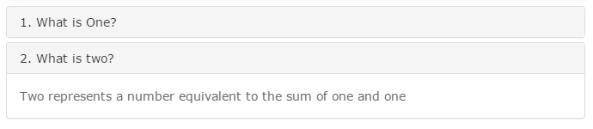

1. As you can see, in the above code ‘1. What is One?’ & ‘2. What is Two?’ are the titles/tabs of the accordion. The content within “<div class=**"panel-body"**>....</div>” is the tab’s content in drop-down.
2. To have tab-title in orange colour, use <h2> instead of <h4>.
3. Notice the ‘in’ class attribute value in <div id=**"collapseTwo"** class=**"panel-collapse collapse in"**>. Adding ‘in’ class allows that tab to be open by default. In above example, 2nd tab is open by default. So, instead, if you would like the first tab to be open by default, remove ‘in’ class from <div id=**"collapseTwo"** and add it to <div id=**"collapseOne"**.
4. To increase the number of accordion tabs, replicate the entire structure shown below:

|  |
| --- |
| <div class=**"panel panel-default"**>  <div class=**"panel-heading"**>  <h4 class=**"panel-title"**>  <a data-toggle=**"collapse"** data-parent=**"#accordion"** href=**"#collapseOne"**>**1. What is One?**</a>  </h4>  </div>  <div id=**"collapseOne"** class=**"panel-collapse collapse"**>  <div class=**"panel-body"**>  <p>**One is a the lowest cardinal number.**</p>  </div>  </div>  </div> |

1. Note that while adding new tabs to accordion, you will have to change ‘**collapseOne**’ for each tab at both positions highlighted in above code. This is required since clicking on the tab will help focus its corresponding content & also because the value of an ‘id’ attribute is unique on for entire page. E.g. *collapseThree*, *collapseFour* and so on.
2. *‘Show all’ link*: It is possible to add a link that will show/expand all tabs of an accordion. To do so, add the below code at the beginning of accordion i.e. before: <div id=**"accordion"** class=**"panel-group bootstrap-accordion"**>

|  |
| --- |
| <div class=**"accordion-show-all-btn"**>  <span>**Show all**</span>  </div> |

1. It is also possible to insert accordion template using WYSIWYG editor. Steps to do the same are as below:
   1. Switch text format to ‘Full HTML’
   2. Click on the template icon in editor’s toolbar.



* 1. Select ‘Bootstrap Accordion’
  2. To see the HTML source/code, click on ‘Disable rich-text’.